DocsTeach iPad App

- Open app.
- Enter a Classroom Code to open the app. You do not have to close reopen the app between uses. Just leave it open.
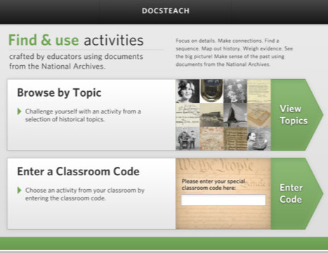

Civil War Day
The Classroom Code for today’s activity is: wec565
Students are to use graphic organizers to record their observations and information. They do not have to use the photo analysis form. It was just an extra form that I threw in.

