Timeline iPad App
by ReadWriteThink.org
Step # 1
Locate the app on your iPad
Step # 2  To create an account  - Click on +New User  - Enter Name & Choose Image  - Click COMFIRM  - Tap to select the user | 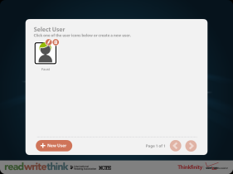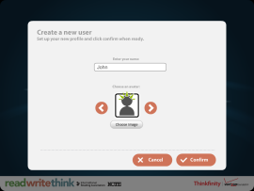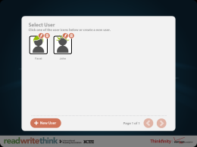
Step # 3  In the PROJECT TITLE box, type the name of the timeline | 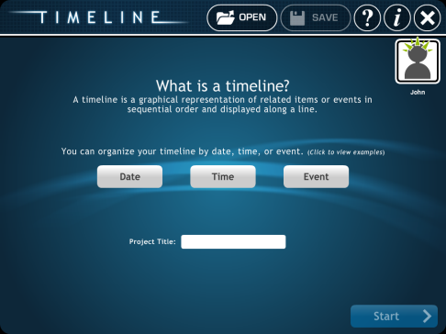
Step # 4  Tap anywhere on the timeline to start entering information | 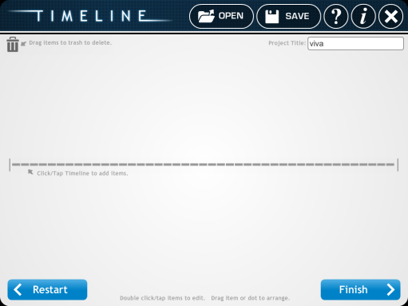
Step # 5  Label: I enter the date here – there is a limited space for characters  Short Description: This will appear on the timeline  Full Description: This will only appear on the timeline outline when it is printed | 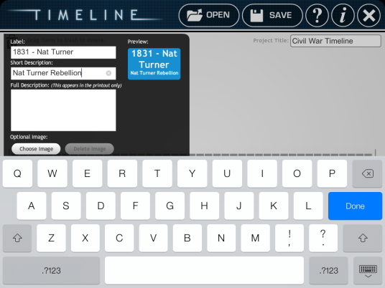
Step # 6  - Continue adding dates to the timeline until it is complete.  - Press FINISH and select SAVE FINAL to save the timeline to the camera roll.  - Click on the X at the top of screen to log off app | 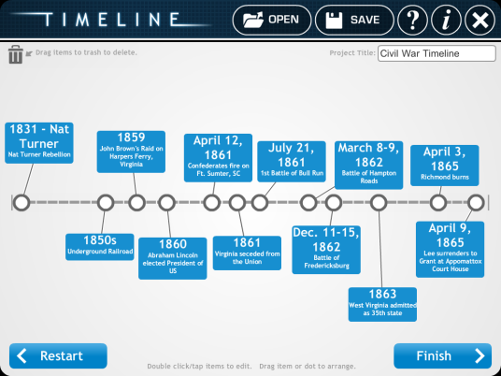
Step # 7  - To save timeline and get it off the iPad – use Dropbox  - Open Dropbox and click on PHOTOS to upload new images. Once this is done you can access Dropbox from a computer and download the images. | 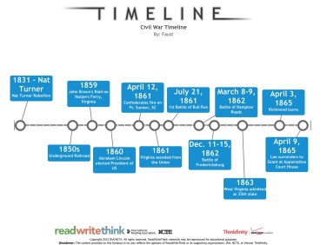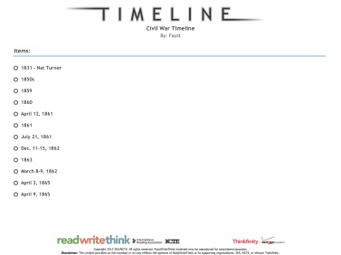

This program is also available online at READWRITETHINK.org.
This is a FREE app available through the iTunes App Store.

