VoiceThread iPad App Directions
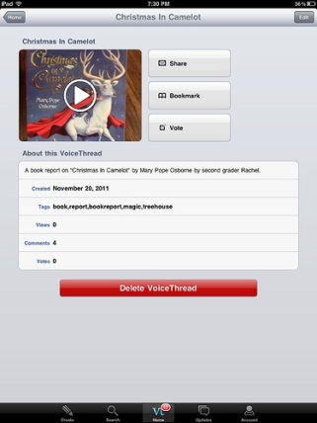
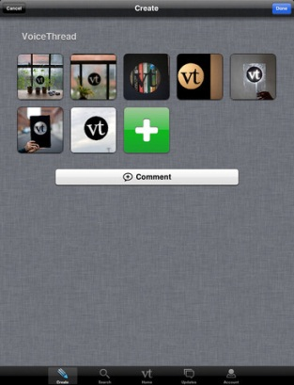
Click on the project to open.
Click on the Voicethread project you want to open.
Civil War Day:
I have created a couple of VoiceThreads so that more than one project can be worked on at the same time.

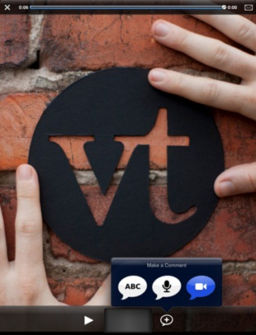
To record:
Click the + sign at the bottom of the project screen and select “ABC.” Wait for prompt and then record message.
NEXT, change the identity before recording another student.

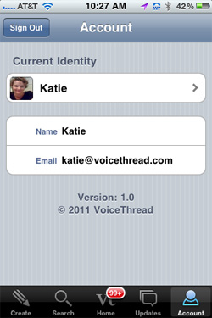
To change your Identity:
- Click the “X” in the upper left hand corner, then…
- Tap the Account tab at the bottom of the screen.
- Tap your current Identity.
- Select another Identity.
- Tap the image of the VoiceThread and reopen the project.

